**DESIGN AND ANALYSIS OF AN ACOUSTIC FIRE EXTINGUISHER**

**PROJECT REPORT**

CERTIFICATE

**DECLARATION**

ACKNOWLEDGEMENT

ABSTRACT

CONTENTS

LIST OF FIGURES

# CHAPTER 1 : INTRODUCTION

Fire is an important process that affects ecological systems around the globe. It is the rapid oxidation of a material in the exothermic chemical process of combustion, releasing heat, light, and various reaction products. The positive effects of fire include stimulating growth and maintaining various ecological systems. Fire in its most common form can result in conflagration, which has the potential to cause physical damage through burning. The negative effects of fire include hazard to life and property, atmospheric pollution, and water contamination. When the risk of an uncontrollable fire is around, firefighting devices are used for containing the fire. Several methods are employed to contain the fire.

A fire extinguisher is an active fire protection device used to extinguish or control small fires, often in emergency situations. It is not intended for use on an out-of-control fire, such as one which has reached the ceiling, endangers the user (i.e., no escape route, smoke, explosion hazard, etc.), or otherwise requires the expertise of a fire brigade. Typically, a fire extinguisher consists of a hand-held cylindrical pressure vessel containing an agent that can be discharged to extinguish a fire.

Fire requires three main elements to sustain itself. Heat, fuel and oxygen are the elements that allow fire to keep burning. Without the sufficient supply of these elements it would be hard for the fire to sustain itself. Thus, extinguishing fire means blocking the availability of any three elements. Water is commonly used as the fire extinguishing agent from the olden times. However, water cannot be used for all kinds of fire. Fires due to flammable liquids or due to electric failures cannot be extinguished by using water. Water when used to extinguish these fires tend to go down due to higher specific gravity than most of the flammable liquids. Water when used to extinguish fires due to electrical failures can pose the risk of electrocution, due to exposed live wires. So, firefighting agents other than water are used to extinguish these kinds of fire.

There are several classes of fire, which are differentiated based on the fuel that the fire is burning on. These classes are different for different countries. According to the Bureau of Indian Standards, the fire is classified as:

1. Class A fire - Fires involving solid combustible materials of organic nature such as wood, paper, rubber, plastics, etc. where the cooling effect of water is essential for extinction of fires.

2. Class B fire - Fires involving flammable liquids or liquefiable solids or the like where a blanketing effect is essential.

3. Class C fire - Fires involving flammable gases under pressure including liquefied gases, where it is necessary to inhibit the burning gas at a fast rate with an inert gas, powder or vaporizing liquid for extinguishment.

4. Class D fire - Fires involving combustible metals, such as magnesium, aluminum, zinc, sodium, potassium, etc., when the burring metals are reactive to water and water containing agents and in certain cases carbon dioxide, halogenated hydrocarbons and ordinary dry powders. These fires require special media and techniques to extinguish.

In addition to these classes there exists two other classes of fire,

1. Class K (formerly Class E – European Standard, Class C – US Standard, Class E – Australian Standard) – Fires involving potentially energized electrical equipment. This sort of fire may be caused by short-circuiting machinery or overloaded electrical cables. Where energized electrical equipment is involved in a fire, non-conductivity of the extinguishing media is of utmost importance, and only extinguishers expelling dry powder, carbon dioxide (without metal horn) or clean agent should be used. Once the electrical equipment is de-energized, extinguishers suitable for the class of the fire risk involved can be used safely.

2. Class F – Fires that involve unsaturated cooking oils in well-insulated cooking appliances located in commercial kitchens. Though such fires are technically a subclass of the flammable liquid/gas class, the special characteristics of these types of fires, namely the higher flash point, are considered important enough to recognize separately. It is suppressed by removal of oxygen or water mist.

For the above-mentioned classes of fire, there are different extinguishers that can be used to suppress them. Below given are the types of fire extinguishers used for the particular type of fire.

1. Class A fires—Water, foam, ABC dry powder and halocarbons.

2. Class B fires—Foam, dry powder, clean agent and carbon dioxide extinguishers.

3. Class C fires—Dry powder, clean agent and carbon dioxide extinguishers.

4. Class D fires—Extinguishers with special dry powder for metal fires.

5. Class E fires – Non conducting extinguishing agents, CO2, PKP

6. Class F fires - Wet chemicals

In this project we aim to introduce a new kind of fire extinguisher that suppresses fire using sound or pressure waves. Using an amplifier and a speaker, emitting a bass sound with a frequency of around 30 Hz the sound waves when directed at the interface of the fire, the concentration of oxygen in the vicinity of the fire gets disturbed. The fire which requires oxygen to sustain also gets affected. Following this, the motion of the pressure waves disturbs the fuel - fire interface thereby acting as the second reason for the fire to extinguish. The earlier design used an amplifier and a speaker to achieve sound. In this project, based on a new design, we use a piston and connecting rod arrangement, to obtain the pressure waves. Since sound waves are actually a series of compressions and rarefactions, these are also called pressure waves because of alternating high pressure and low-pressure regions. So, pressure waves and sound waves can be used interchangeably in this scenario.

# CHAPTER 2 : LITERATURE SURVEY

# CHAPTER 3 : DESIGN OF ACOUSTIC FIRE EXTINGUISHER

In this project the fire fighting method is based on the use of sound waves to extinguish the fire. In the design phase, the initial idea consisted of using a subwoofer to produce the sound waves of the required frequency. The literature survey conducted showed that the optimal frequency to extinguish the fire was around 30Hz. A 3-D CAD software, SolidWorks was used to design the model of the acoustic fire extinguisher. Ansys was used for the detailed studies and simulation of the model.

**Initial Design:**

The design consisted of a subwoofer, frequency generator, an amplifier and a vortex tube. The frequency generator was used to produce a low frequency of 30Hz, and the amplifier was used to amplify the signal. Using a subwoofer, the sound waves were produced in the region of 30Hz. The components were arranged and connected in the following order:

Frequency Generator -> Amplifier -> Subwoofer -> Vortex tube

The produced sound waves then travelled from the subwoofer, along the vortex tube. The end of the vortex that is exposed to the fire, consisted of a hole of the required diameter. It was designed to produce a vortex wave that would be aimed at the fire. As discussed earlier, the wave would disrupt the oxygen concentration and the flame – fuel interface, preventing the fire to sustain itself. A brief description of the components and their corresponding functions is given below:

1. Frequency Generator :

A frequency generator is a class of electronic devices that is used to produce a signal of the required frequency. In this project, the use of a frequency generator is to produce a sound wave having a frequency of 30Hz.

1. Amplifier :

An amplifier is an electronic device that can increase the power of a signal (time varying voltage or current) It is a two-port electronic circuit that uses electric power from a powersupply to increase the amplitude of a signal applied to its input terminals, producing a proportionally greater amplitude signal at its output. This is used to prevent the loss of the signal which is obtained from the frequency generator.

1. Subwoofer

A subwoofer (or sub) is a loudspeaker designed to reproduce low-pitched audio frequencies known as bass and sub-bass, lower in frequency than those which can be (optimally) generated by a woofer.The typical frequency range for a subwoofer is about 20–200 Hz for consumer products, below 100 Hz for professional live sound, and below 80 Hz in THX-approved systems. The subwoofer emits the sound that acts as the fire fighting agent.

1. Vortex Tube

This is a cylindrical tube whose one end is connected to the subwoofer and the other end is exposed to fire. The side exposed to the fire, also known as fire-side contains a hole, of a particular diameter. This hole helps in producing vortex waves, which extinguishes the fire.

**Second design:**

The earlier design consisted of electronic components that were used in the production of sound waves. Sound waves being pressure waves, and replacing those electronic components with mechanical ones one can obtain the same result. Here, an inversion from the slider crank mechanism is used in designing the mechanical system. The piston and connecting rod arrangement is used to produce the alternating pressure regions. Instead of the piston a suitable material that can fit and move easily inside the vortex tube is used as a diaphragm. The forward movement of the diaphragm produces a high-pressure region called the compression and the backward stroke produces a low-pressure region called the rarefaction. So, an alternating propagation of these regions gives us a moving pressure wave. The design of the fire extinguisher in this way, gave the opportunity to control the amplitude of the pressure wave, the frequency, which in turn allowed to control the velocity of the pressure wave. This acts in the same principle as the above design. A brief description of the above components are given below:

1. Connecting rod:

A stainless steel connecting rod is used for converting the rotational motion of the steel disc into the reciprocating motion of the diaphragm.

1. Steel dsc:

The steel disc performs the function of the crank. It contains a rectangular groove, onto which one end of the connecting rod is bolted. The distance of the bolted joint from the centre of the steel disc, allows to control the stroke of the movement of the connecting rod, thereby controlling the amplitude of the pressure wave.

1. Electric motor:

This is used for providing the system of the slider crank arrangement motion. The rotary motion of the motor shaft is converted to reciprocating linear motion using a connecting rod. The motor selected for the above application must have high torque, with a decent amount of speed. We selected the RS-775 DC motor with rated voltage of 12-24 Volts and rated current of 2.6 Ampere which has a maximum rotational speed of 7000rpm.

1. Gear arrangement :

The gear arrangement used in the project was for reducing the speed of the motor to the required values. The motor selected for the above application had high speed at a no load condition, higher than the required amount. So a reduction gear setup was used to reduce the speed to the required levels.

1. Battery:

Used to provide power to the electric motor. A 12V battery was only required for this situation.

# CHAPTER 4: CALCULATIONS WITH CURRENT DESIGN

## **Power Required**

With the current finalised design we calculated the velocity of diaphragm, force acting on diaphragm, power required by the motor for the different values of frequency,diameter of diaphragm and amplitude.

The average velocity of the diaphragm is found out by considering the stroke length of diaphragm and rotational speed of the crank.

Average velocity, =

After finding the velocity of the diaphragm we can compute the viscous force acting on the diaphragm using the equation

By using this we can find the power required to produce the pressure waves at the required rpm using the equation,

So there are three variables we can change - Rotational Speed, Stroke, Radius of Diaphragm- to alter the pressure waves produced by it. Now keeping Separately one of them a constant, we can plot a 3-Dimensional Graph to plot the power requirement for all the cases.

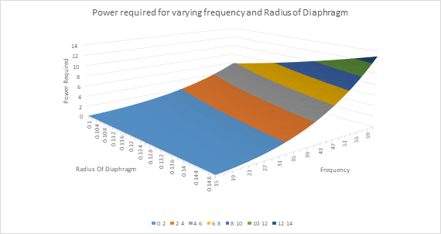

By Keeping the Stroke, a constant value of 0.05m, we varied the Radius of Diaphragm and frequency and found out the required power and plotted it on a graph.

As expected we can see that with increasing frequency we would be requiring more power.

Next we plotted the variation of power with varying Stroke and Frequency. Also we checked the variation in power with varying Stroke and Radius. Both these showed similar results.

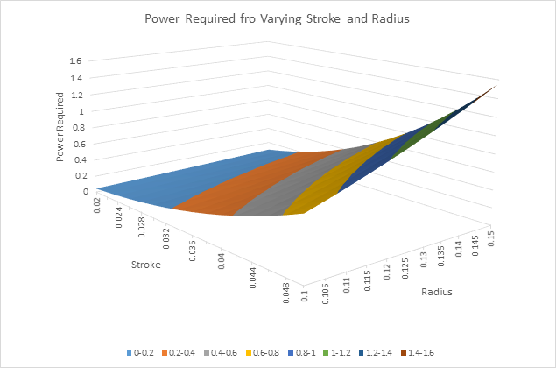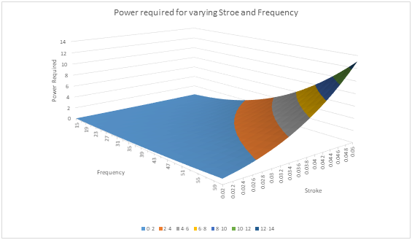

We understand that frequency has the most effect and the maximum power required is approximately 13.5 Watt at its peak frequency, stroke and radius of diaphragm.

## Rotational speed Calculations

From the figure we can easily see that the design is similar to the crank and piston mechanism in an engine.

So we find the direct correlation between frequency of pressure waves and rotational speed of the crank.

Frequency =

Based on this we can estimate that at the maximum frequency required of 60Hz we need the crank to rotate at 3600rpm.

## Bought Items based on Calculations

The motor required to produce the pressure waves should produce a minimum of 14 Watt for smooth operation under optimum conditions subjected to maximum value of different parameters.

Min power required by motor = 14 Watt

Also we have concluded that the crank should rotate at a maximum rpm of at least 3600 rpm

Frequency range required for the motor will be from 1800 rpm(30Hz) to 3600rpm(60Hz).

So based on the requirements we used the RS-775 DC motor with rated voltage of 12-24 Volts and rated current of 2.6 Ampere which has a maximum rotational speed of 7000rpm. The speed can be stepped down to required rpm with a small gearbox. We selected a gearbox with gears of 11 and 24 teeth which produces a reduction of 2.18:1. This will help produce rotational speed of upto 3211rpm(). This is good enough for our experiment.

# CHAPTER 5 : ANALYSIS OF ACOUSTIC FIRE EXTINGUISHER

The analysis of the acoustic fire extinguisher was done by introducing a User Defined Function(UDF) to produce the transient flow because of the varying direction and magnitude of the flow of air in the vortex generator. Since we achieved this reciprocating motion with the help of a rotating crank which is at a predefined rpm, the UDF was also defined as a sinusoidal wave. This will help produce the most accurate results. The UDF used is as follows:

|  |
| --- |
| #include "udf.h"  DEFINE_PROFILE(unsteady_velocity,thread,position)  {  face_t f;  real t=CURRENT_TIME;  begin_f_loop(f,thread)  {  F_PROFILE(f,thread,position)=6*sin(30*t);  }  end_f_loop(f,thread)  } |

## **Defining the UDF**

Here the code shown is written in C Programming Language. The parameters such as frequency, Velocity of flow are adjusted here during the compiling of this code.

|  |  |  |  |
| --- | --- | --- | --- |
| Sl No. | Code | Definition | Remark |
| 1 | #include "udf.h" | file inclusion directive | will cause the udf.h file to be included with your source code. |
| 2 | DEFINE_PROFILE(unsteady_velocity,thread,position) | Custom Boundary Profile | define a custom boundary profile that varies as a function of spatial  coordinates or time. |
|  | unsteady _velocity | Parameter of DEFINE_PROFILE | Generates profile for X velocity |
| 3 | face_t f | Data Type | face_t is an integer data type that identifies a particular face within a face thread. |
| 4 | real t=CURRENT_TIME | To look up real flow time | Finds real flow time and stores it in variable t |
| 5 | begin_f_loop(f,thread) | face looping macro | loops over all interior and  boundary zone faces in a compute node |
| 6 | F_PROFILE(f,thread,position)= | Define the face for UDF | Uses integer position to set X velocity face value in memory |
| 7 | 6*sin(30*t) | Parameters definition | 6: Maximum Velocity in sinusoidal flow(m/s)  30: Frequency of Oscillation(Hz) |
| 8 | end_f_loop(f,thread) | face looping macro | Ends the loop |

Using this UDF, we can use Ansys to simulate the flow in an acoustic fire extinguisher with varying parameters with ease.

## The parameters

The parameters we are focussing on are the stroke length, frequency and the area of diaphragm. Variation was made by :

|  |  |  |
| --- | --- | --- |
| Sl No | Parameter | Mode to change |
| 1 | Stroke Length(s) | The maximum velocity of the reciprocating parts can be found by V = which can be varied in the UDF. |
| 2 | Frequency(f) |
| 3 | Area of Diaphragm(A) | Area, A = , *d* can be changed by changing the model dimensions used for the simulation. |

## DesignModeler : Describing the fluid Domain

The analysis was done in Ansys Fluent, and the design was done in DesignModeler, which is a parametric geometry creation tool as part of the Ansys software. For getting the most accurate result with the least amount of computation, only the modelling of the fluid domain was done and the rest of the design were excluded. For further simplification of the computation, only a single slice in 2D was used for the computation. This was possible due to the radially symmetric structure of the vortex generator.

The 2D representation of the fluid domain is shown below:

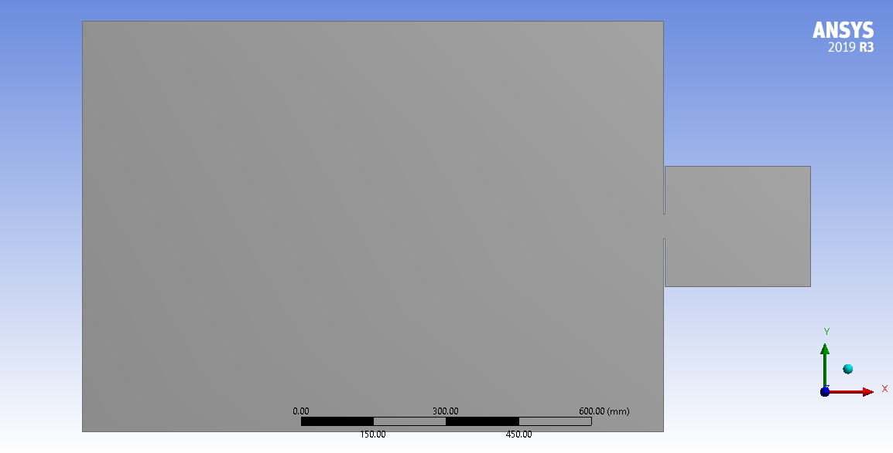

The overall dimension of the fluid domain is as shown and for analysing the path followed by the vortex generated, an additional fluid domain which is 1200 mm in length and 700 mm in height is also created.

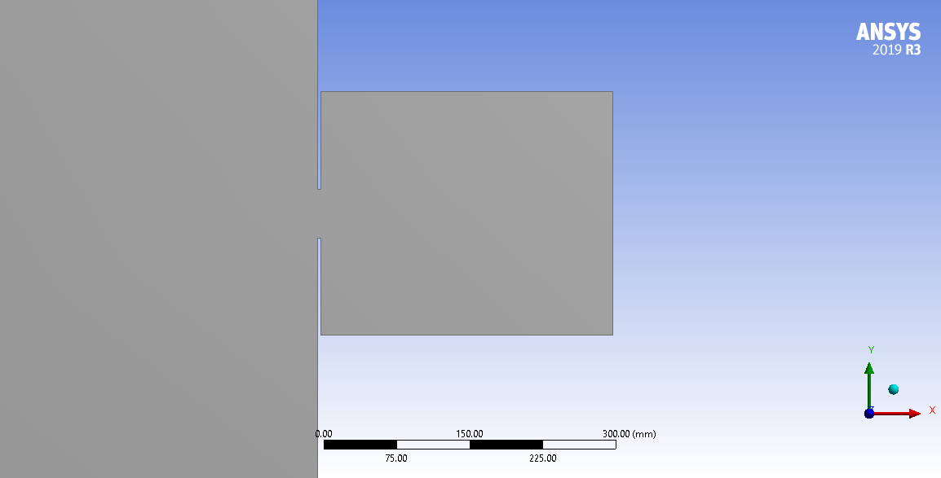

The eyelet in the vortex generator is made by creating a slit at the end of the vortex tube. This will prevent the Ansys solver from creating unpredictable values.

## Meshing

Proper meshing is a definite requirement for any simulation. A solver with fluent was chosen and an element size of 12 mm was taken as the default element size. This will allow for enough clarity in visualizing the streamlines developed from the created vortex.

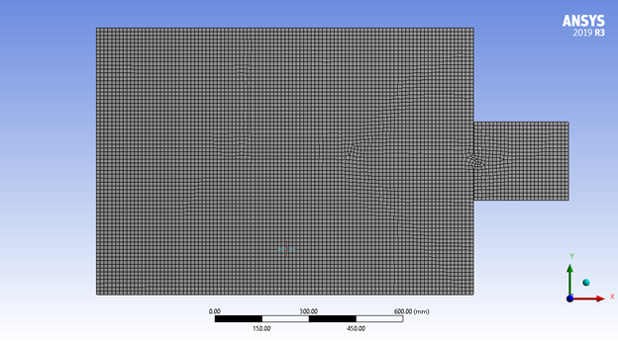

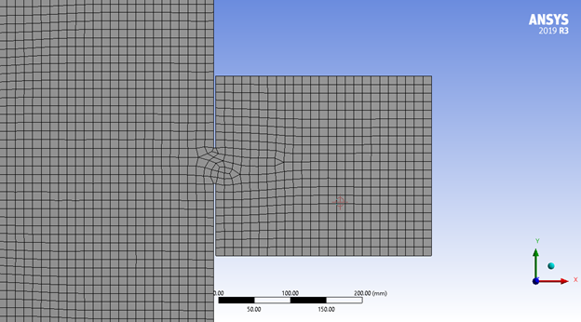

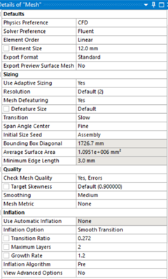

Other parameters of the mesh are shown here. Since the geometry is not a complex one, most of the default values were perfect for the analysis done.

## Declaration of named ranges

Named Ranges are a great way of tagging a particular body, face or an edge so that while computing and declaring the boundary conditions, we can easily reference the required element to the required condition.

So the naming of the elements was done as shown below.

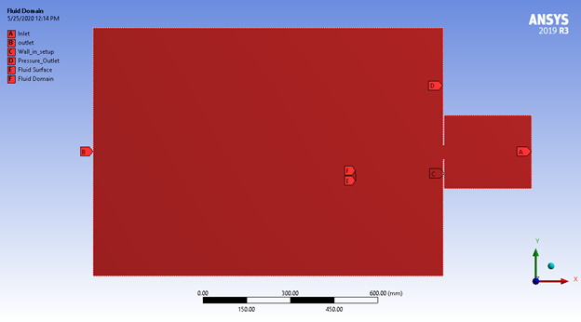

## Setup for Simulation

For maximum precision, the Double precision mode was switched on and the analysis type was set to 2D.

### **General**

Since analysis is a time dependent, the transient solver is used and since the change in density is negligible, the pressure based solver was used.

### **Models**

The k-epsilon model was chosen with all the default parameters.

All other models were turned off as they were not necessary

### **Materials**

Since only the fluid domain is designed, air was taken as the material which was taken from the fluent database. All other parameters were set to the default value.

### **Cell Zone conditions**

From the named ranges, the element named Fluid Domain was declared as the domain of air.

### **Boundary Conditions**

#### **Inlet**

This is the position where the created User Defined Function(UDF) has to be implemented and the x- velocity was declared as the UDF. Y-Velocity was left at 0 as it is negligible.

#### **Outlet**

The Named ranges specified as the “Outlet” and the “Pressure Outlet” were declared under the outlet boundary condition as these are regions of zero-gauge pressure i.e. the atmosphere.

#### **Wall**

The named range specified as the “wall-in-setup” was taken as the wall and no exchange of matter will take place along this boundary.

### **Initialization**

The standard initialization which was computed from the inlet was used for the initialization of the solution.

### **Running Calculation**

For calculation, the time-step size was determined from the frequency of oscillation of the diaphragm. If the frequency was f. then every seconds, the diaphragm oscillates once. So if we need to split this oscillation into n steps for better resolution, then the time step size has to be . The number of time steps was taken to be any multiple of *n.*

## 

## Results

For better understanding of the vortex and the dependency it has with the parameters under consideration, 6 simulations were done with varying parameters.

### 

### 

### **Diaphragm diameter = 300 mm, Frequency = 60 Hz, Stroke = 50 mm**

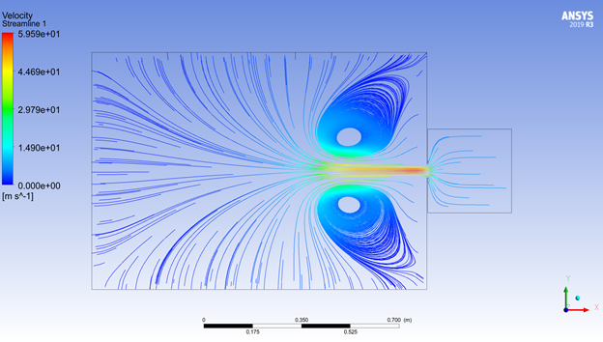

### **Diaphragm diameter = 300 mm, Frequency = 45 Hz, Stroke = 50 mm**

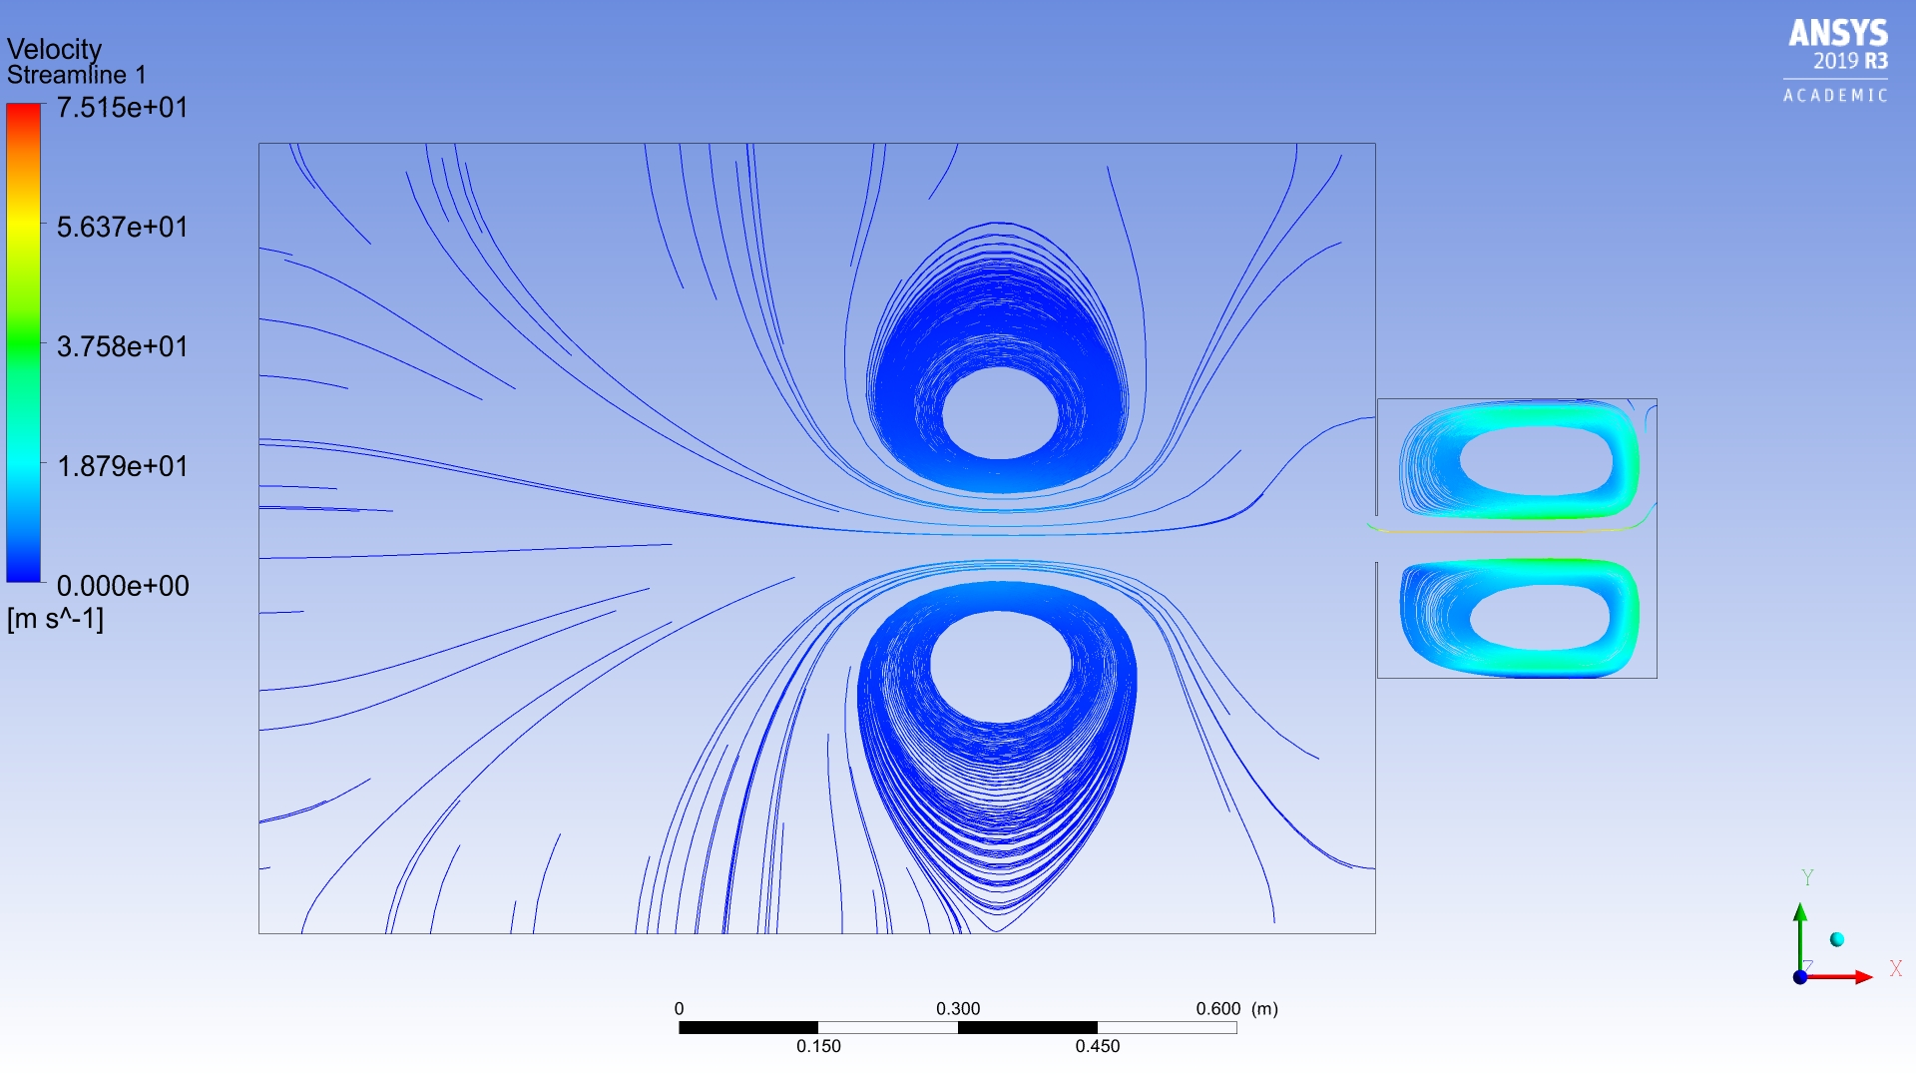

### **Diaphragm diameter = 300 mm, Frequency = 30 Hz, Stroke = 50 mm**

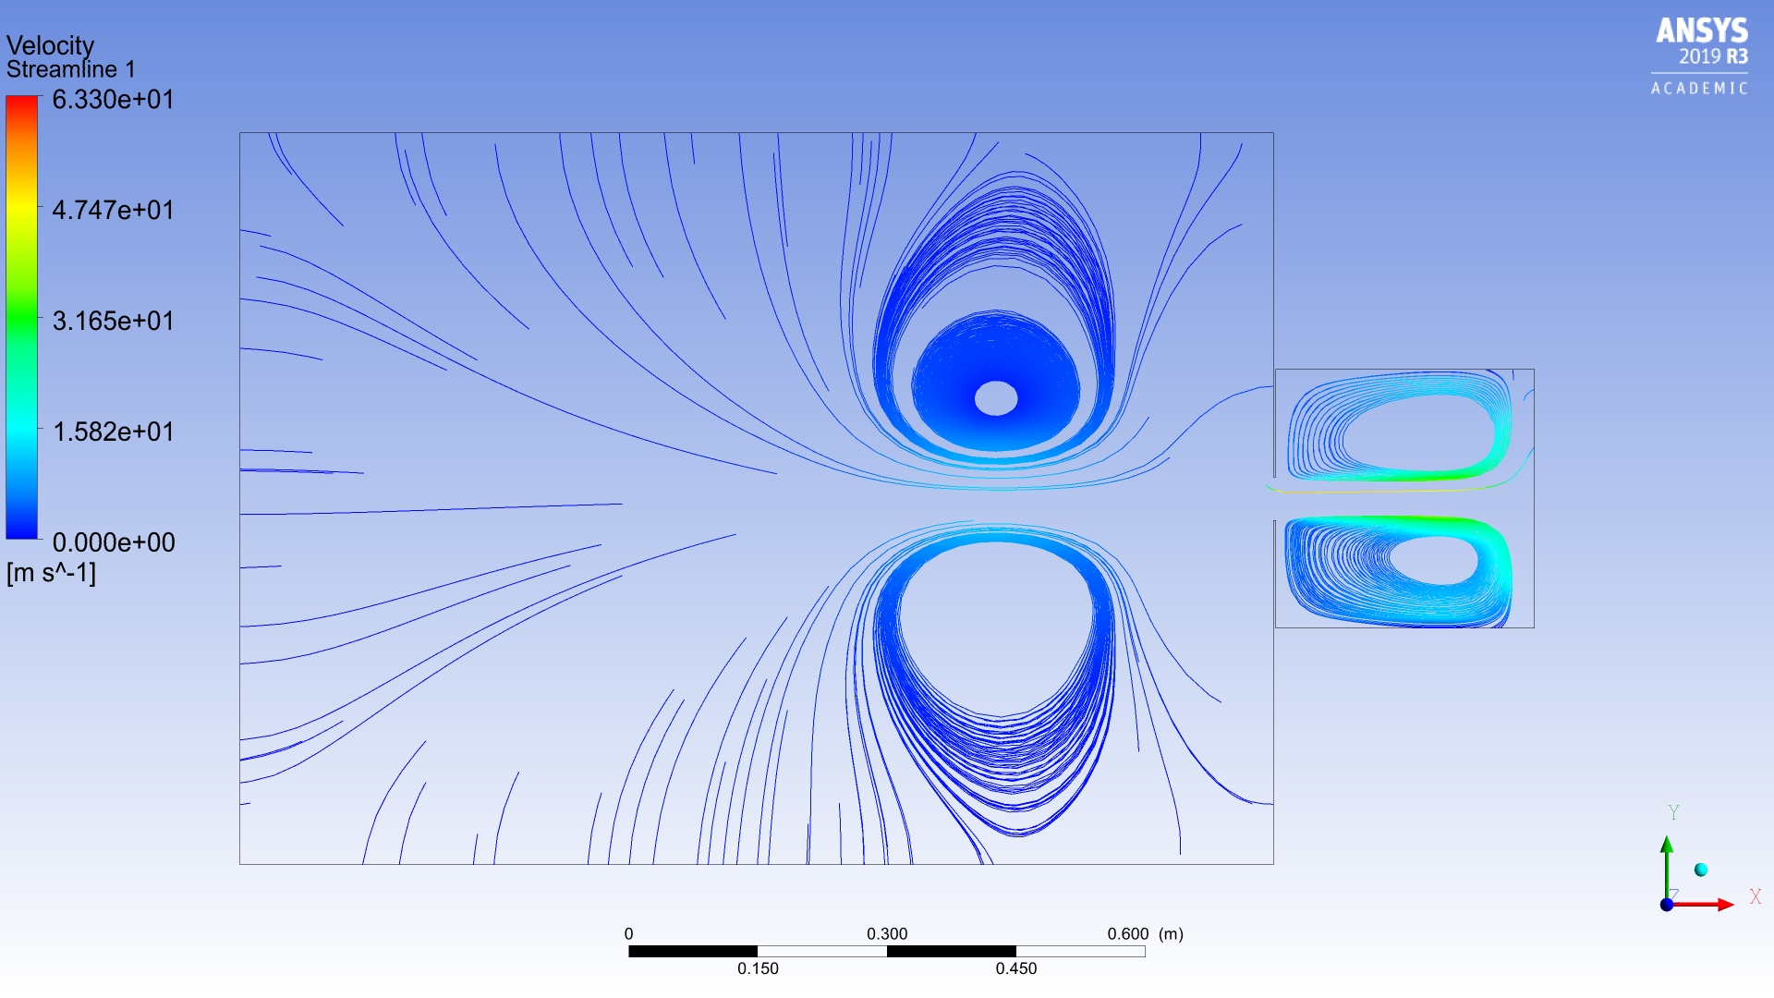

### **Diaphragm diameter = 250 mm, Frequency = 60 Hz, Stroke = 50 mm**

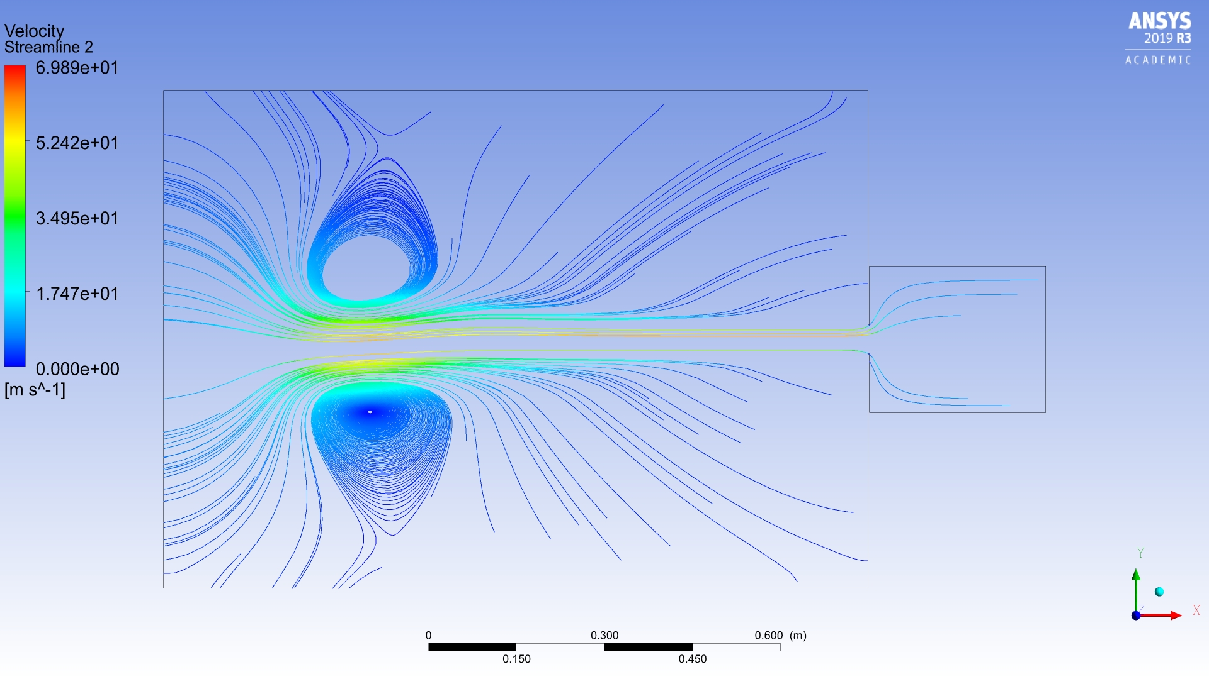

### **Diaphragm diameter = 250 mm, Frequency = 45 Hz, Stroke = 50 mm**

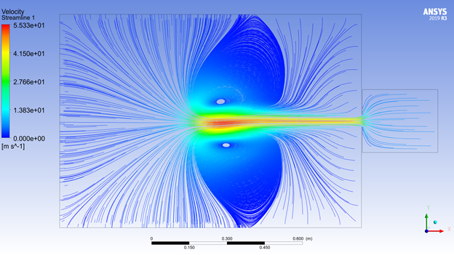

### **Diaphragm diameter = 250 mm, Frequency = 30 Hz, Stroke = 50 mm**

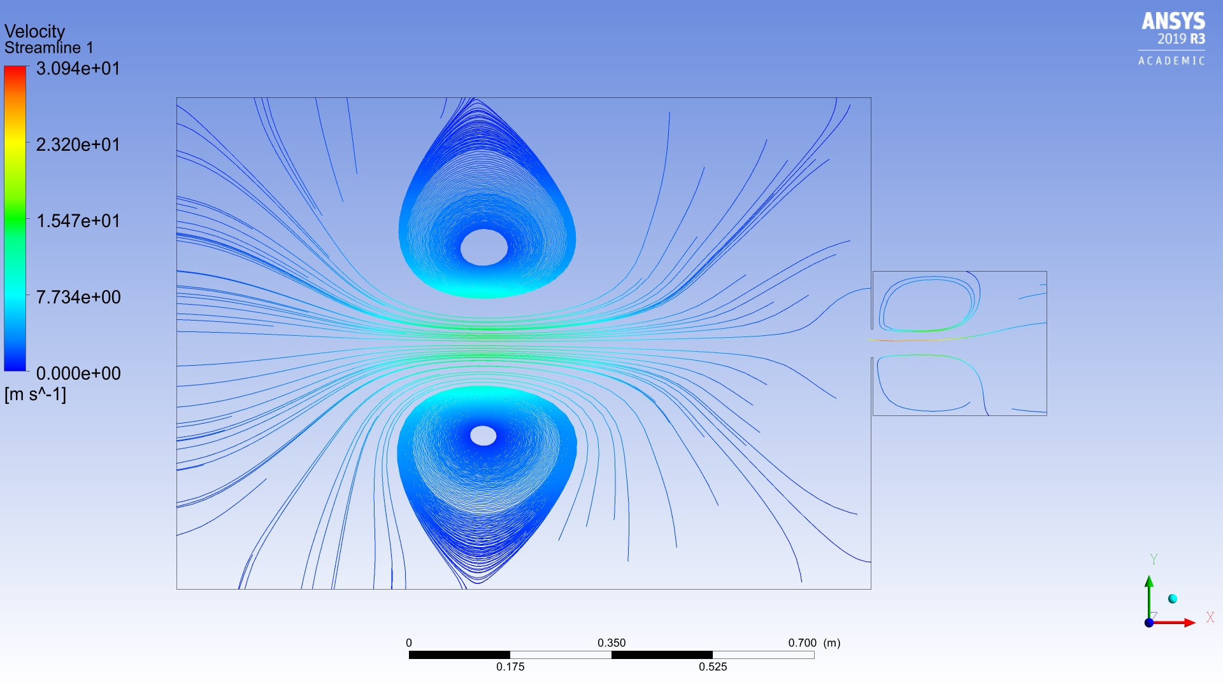

## Inference from Result

From the above conducted analysis, we find that the optimum condition for the best vortex is at 45Hz. Moreover we also find that as the diaphragm diameter increases, there is also an increase in volume of air being pushed out of the vortex generator. But from “CHAPTER 4 : CALCULATIONS WITH CURRENT DESIGN “ it was concluded that with increasing diameter of diaphragm, the power required also increases. So with our current design an optimal size of 300 mm diameter with a frequency of 45 Hz.

# CHAPTER 6 : WORKING

The extinguisher uses mechanical components to produce the fire extinguishing action. A diaphragm, steel plate, connecting rod, electric motor and a gearbox are the major components of this extinguisher. The entire mechanism is based on the crank and slotted lever mechanism. The quick return action of the above mechanism is not incorporated in this extinguisher.

In this mechanism, the rotary motion is converted into reciprocating motion of the connecting rod. The mechanism consists of an arm attached to a rotating disc that moves at a controlled uniform speed. Unlike the crank, the arm of the mechanism runs at a different rate than the disc. Here , in this project a steel disc acts as the crank. Instead of a slotted lever, the steel disc crank contains a rectangular slot onto which one end of the connecting rod is bolted. Now on varying the position of the bolted end of the connecting rod, one can vary the stroke length thuschanging the amplitude of the pressure waves.

The power required to run the apparatus is provided by a motor of specifications, 12-24 Volts and rated current of 2.6 Ampere which has a maximum rotational speed of 7000rpm. This motor is powered by a 12V battery. The reason we chose this particular motor was based on the calculations performed on the previous page. The power required to operate was calculated using the standard power equation and from it the required power of the motor to be operated was obtained. Since the motor we selected had a velocity higher than the recommended value, a gear arrangement was attached to reduce the rotational speed of the motor to required values. The gear arrangement was a reduction gear arrangement, consisting of two gears, each having eleven and twenty four teeth. With these gears the obtained gear reduction ratio was 2.18 : 1, which reduced the speed to 3112 rpm, from which we can obtain 55Hz frequency. How we obtained 55hz from the reduced velocity is shown in the calculations section.

Now, on obtaining such a frequency, this meant that the reciprocating motion of the piston undertook, the number of strokes equal to the obtained frequency per minute. This reciprocating diaphragm is fit inside a vortex generator. The vortex generator is a cylindrical tube, where on the fire side a hole is present through which vortex pulses come out and through the other end, the diaphragm - connecting rod attachment is provided. The reciprocating motion of the diaphragm that is the alternating forward and backward movements of the diaphragm produces regions of high and low pressure. While these regions are pushed out through the hole in the fire side, vortex pulses are produced. The analysis of the above said mechanism was carried out using Ansys Fluent and vortex waves were observed coming out from the hole. The vortex waves being stable could travel distances. The vortex waves consist of regions of high oxygen concentration and a region of low oxygen concentration. When the vortex wave travels towards the fire, it disturbs the stable burning and extinguishes it. In order to understand how the fire is put off, we have to understand how the fire burning mechanism works.

Fire needs three basic elements for it to burn, which are heat, fuel and oxygen. Fire extinguishers work by preventing the supply of any one above said elements. Carbon dioxide extinguishers reduce the concentration of oxygen around the fire and provide a blanketing effect over the fire, while water suppresses fire by reducing the heat along with various other effects.

In the acoustic wave extinguisher, when the vortex wave approaches the fire, it contains regions of low oxygen concentration. This vortex when it hits the fire, disturbs the concentration of the oxygen around the fire and also the fire - fuel interface. This disturbance prevents the sustained burning of fire. And this effect is depicted for a single vortex. Now when this vortex is provided at a particular frequency then the sustained burning of the fire cannot be achieved, thereby reducing the burning effect. Now as the flames are disturbed by the pulsating vortex waves, the temperature around the area also reduces, which further reduces the fire’s ability to sustain. When these factors combine together they have a drastic effect on the burning of fire. This extinguishes therefore achieving safety.

# 

# 

# CHAPTER 7 : ADVANTAGES AND DISADVANTAGES

# 

# CHAPTER 7 :

# CHAPTER 8 :

# CHAPTER (N): CONCLUSION

# CHAPTER (N+1): REFERENCES